DR. CHARLES C. WARFIELD

Metropolitan Kalamazoo Branch
NAACP
YOUTH COMMUNITY SERVICE AWARD

The Dr. Charles C. Warfield Youth Community Service Award was created to celebrate the success of youth who are involved in community service throughout the Kalamazoo/Portage vicinity. The late Dr. Warfield was a quintessential leader and community activist and served as president of the local NAACP branch and Education Chair for the NAACP Michigan State Conference for 8 years. He was active in many organizations and participated in a cadre of activities. His legacy will continue to resonate in our organization and throughout our community.

This prestigious award will acknowledge the fine efforts of a local African American high school senior who embraces the spirit of diversity, while being energetically and enthusiastically engaged in community service, community projects, and other community-based activities.

The Kalamazoo Branch will bestow a $500 award, along with a one-year NAACP youth membership to a high school senior residing in the Kalamazoo/Portage area. The award recipient will also receive a total of three complimentary tickets (one for the recipient and two for guests of the recipient) to attend the annual Freedom Fund Banquet on
Saturday, November 2, 2019 at 5:00 p.m. at Western Michigan University’s Bernhard Center.

If you meet the above criteria, please consider nominating yourself for this noteworthy award! The nomination form must be received by mail or email by October 14, 2019.

NOMINATION GUIDELINES
CRITERIA:
- The nominee must be an African American high school senior at a local high school.
- The nominee must reside in the Kalamazoo/Portage area.
- The nominee must be actively engaged in community service efforts.

INSTRUCTIONS:
- Applications must be typewritten or neatly printed.
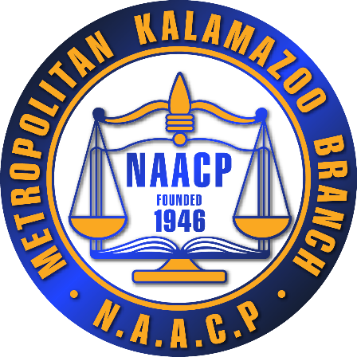
- When completing application, please use the full name of awards, clubs, and organizations (no acronyms). Attach other sheets if additional space is warranted.
- The completed nomination form must be completed online

For additional information, contact Sadie Clark Miles (269-808-4565).

ALL NOMINATION FORMS MUST BE RECEIVED BY OCTOBER 14, 2019

Vital Information

Student’s Name

Home Address
Telephone Number |  | Email Address
High School |  | Parent(s) Name

Please list your community service affiliations, activities, and officers held (if applicable):

Please indicate how you have made a significant impact in the Kalamazoo/Portage community by embracing the spirit of diversity:

The Metropolitan Kalamazoo Branch NAACP continues to be at the forefront of community service and social justice. How have recent national events impacted you (e.g., the murders of innocent children, police brutality, inequities in education, etc.)

What are your future goals and aspirations?

Please provide additional facts the judges should know that may be relevant to the nomination selection process.

PLEASE LIST THE NAMES AND NUMBERS OF THREE PEOPLE WHO WOULD SERVE AS REFERENCES (TEACHER, MENTOR, COUNSELOR, PASTOR, ETC.):

NAME |  | EMAIL ADDRESS | CELL NUMBER
1.

2.
3.

I hereby certify all of the above information is true and accurate to the best of my knowledge. Any intentional misrepresentation or omission of facts will be justification for denial of this award.

______________________________________________________________|_________________________
Signature Date

